Lab 3 – Synthesis
Omri Raz – 318671120
Eyal Rothschild – 318793882

13.01.2026

Our System:
FSM diagram:
This is our FSM diagram.
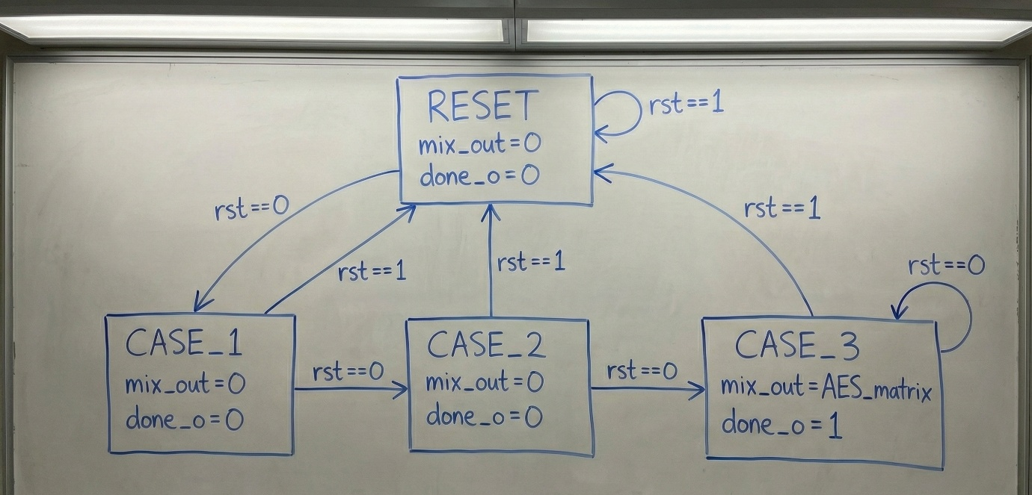

Logic Design:
In the next images we will show the Logic Design of the system.
FSM:
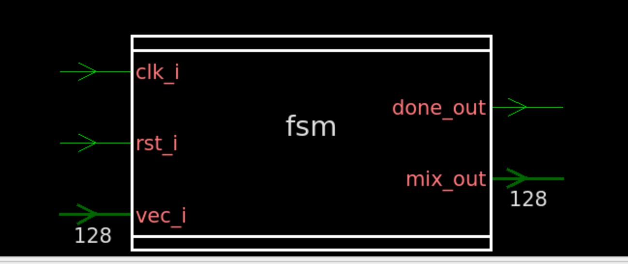
As shown in the schematic diagram, the FSM operates synchronously. The transition to the next state is a function of the current state, triggered by the rising edge of the clock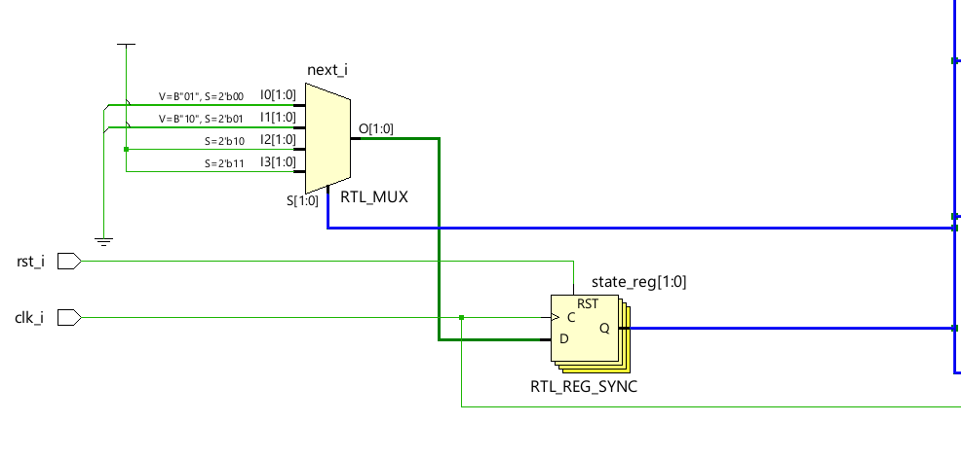

Mix Collumns operation:
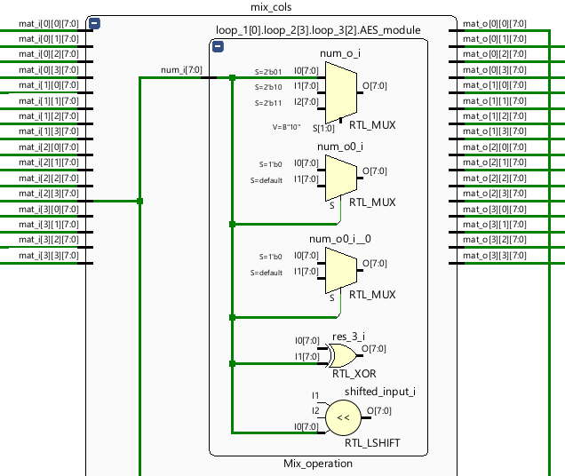
In this RTL implementation, the mix_cols transformation is conditional ,the output varies according to the specific polynomial coefficients applied in the current mode, using the submodel Mix_operation.

The ‘done’ signal:
The following image illustrates the implementation of the done output signal. By utilizing a registered output, we ensure better synthesis results and improved timing stability.
Furthermore, it can be observed that the mix_out signal is only valid when the done signal is asserted.
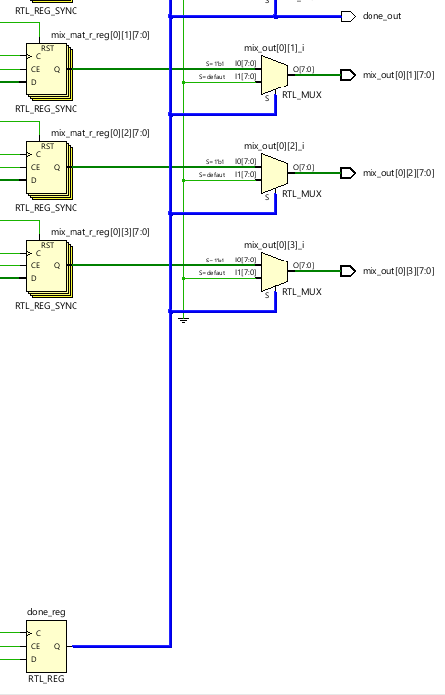
Verification:
The verification requirements have been fully implemented and verified.
Implementation methods:
- We have created a “golden model” of the system using python. First, we ran random simulations in TB using randomized input vectors.
The simulation was configured for repeatability, allowing reuse of random vectors by applying a consistent seed – we insert the random vector into our “golden model”, retest and compare the expected output with our system output.
Theoretically we could test unlimited random vectors, however we decided to test only 15.
In addition, we have created local signals in our TB that indicate if there is a mistake.

We also checked edge cases manually – for example:
vec_i = ‘0;
Vec_i =’1;

- we created coverage – ensure that TB checked each module and part in the FSM.
- We created assertions – validate the system’s functional correctness by verifying both its state transition logic and accuracy of its output signals.
- We create BFM to help us with the simulation.
- We ensured all operational stages are completed with the output held in the FSM, followed by the done_o signal acting as a completion flag in a stable and valid state by creating register output.

TB results and examples:

In the next picture we can observe our coverage.
We achieved 100% functional coverage, ensuring that all FSM states were reached and all defined transition were successfully traversed.
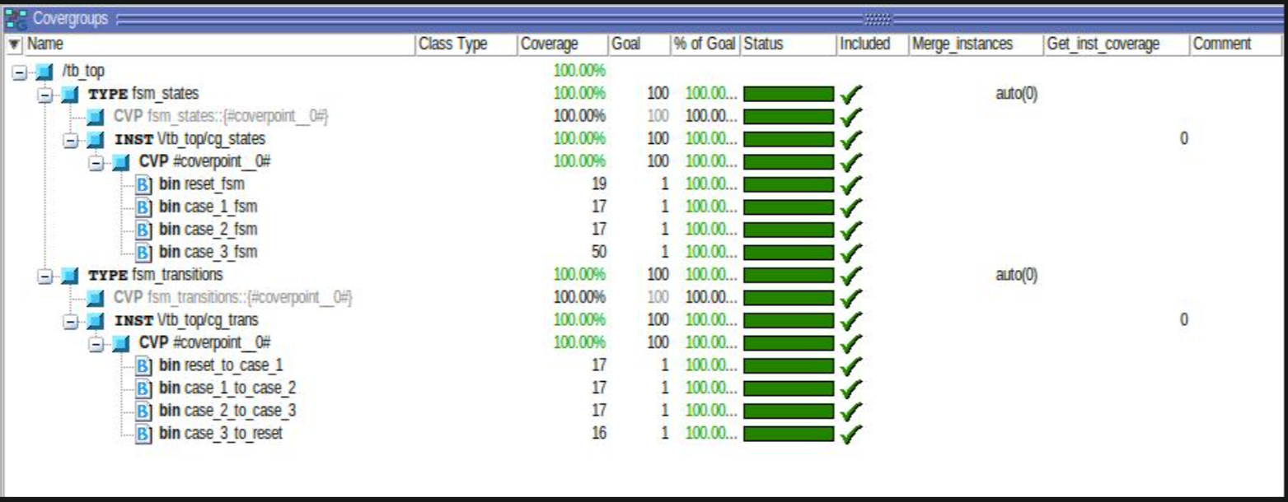

In the next image we can observe our assertion.
All our assertions passed.
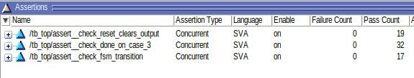

The next photo explain why we got way more “check_done_on_case_3” (we checked done_o in next cycle) assertions – our TB force the system to hold CASE_3 for 3 cycles, in addition this assertion is checked only when rst == 0.
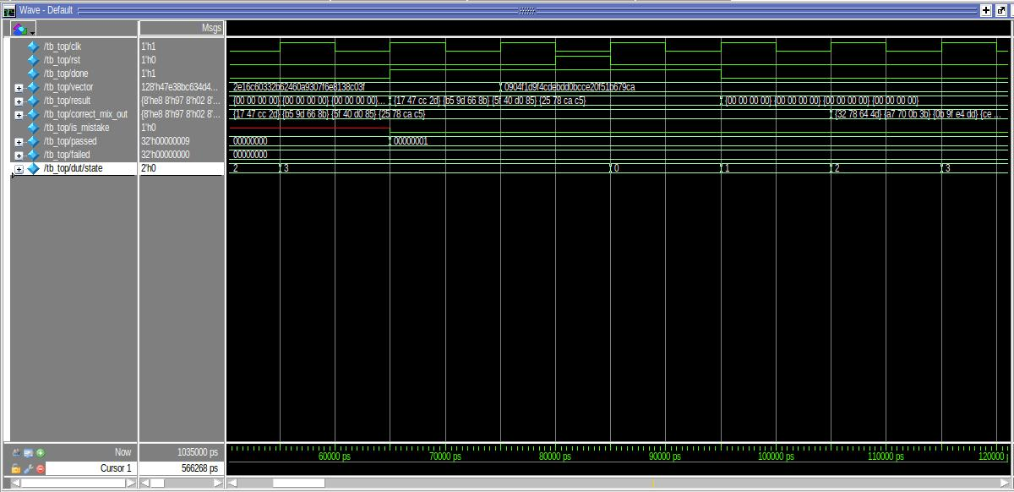

The next photo explains why our reset assertion is bigger than 17:
Our TB is set reset to 1 for 2 cycles at the beginning of the simulation.
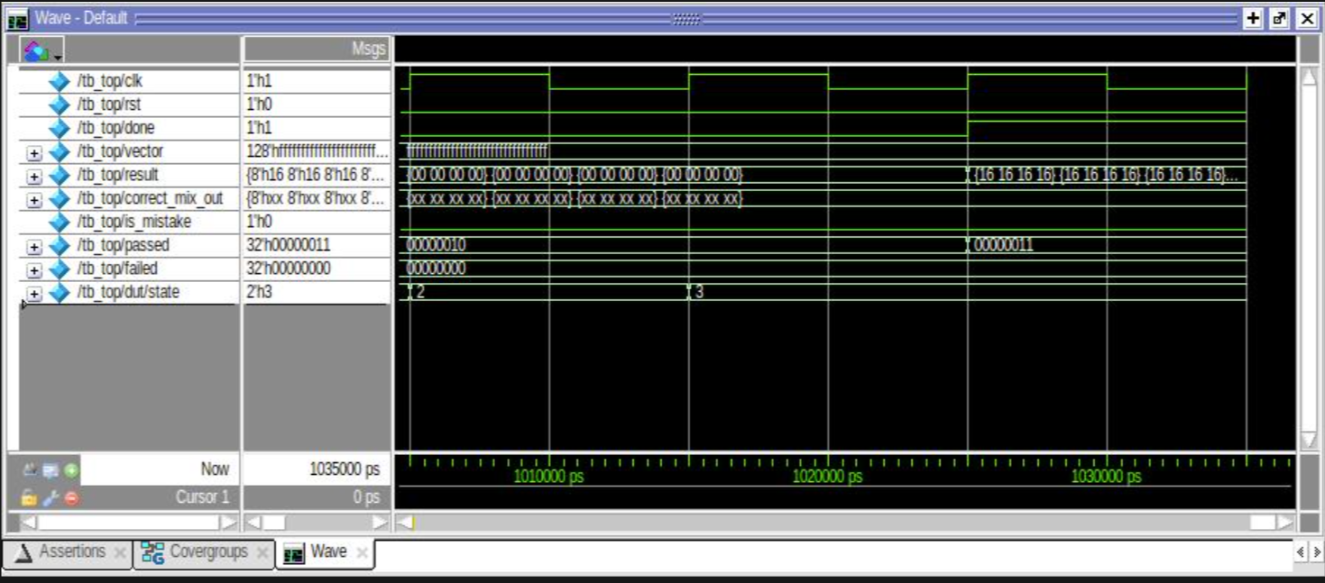

The next photo shows that we passed all our tests!
we can observe the signal “is_mistake” is zero and passed count eqaul to 17 !!!!
good job!

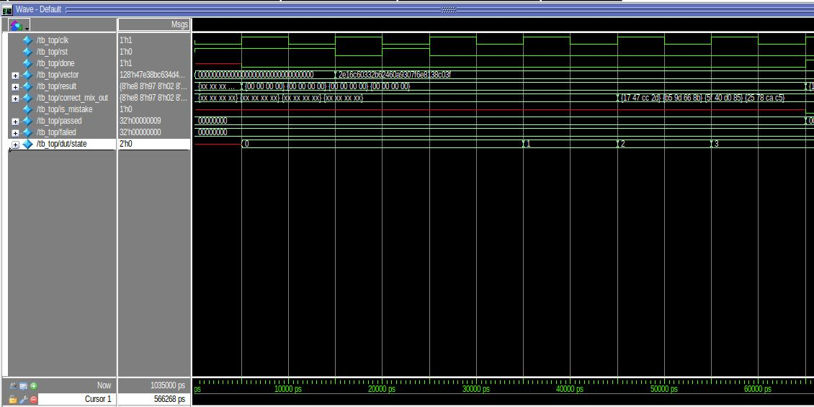

- We added coverage and assertions files in submissions files.
Synthesis – Gate Level Testing:
We were asked to implement gate level verification, the next images describe it .
As you can see by the data below, the ‘is_mistake’ flag is 0 for every input vector, meaning that the output of the system is the same as the golden model.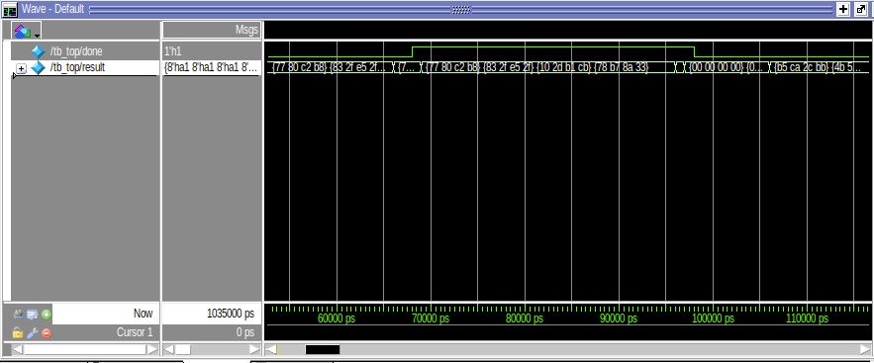

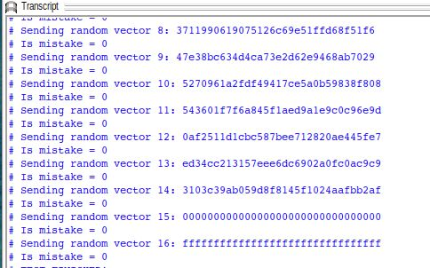
Transcript:
run
# ** Warning: (vsim-7) Failed to open readmem file "/users_home/eyalroth/Lab_2/TB/golden_model_questa_out.memb" in read mode.
# No such file or directory. (errno = ENOENT) : /users_home/eyalroth/Lab_3/TB/fsm_tb.sv(50)
# Time: 0 ps Iteration: 0 Instance: /tb_top
# Starting random test...
# Sending random vector 0: 2e16c60332b62460a9307f6e8138c03f
# Is mistake = 0
# Sending random vector 1: 0904f1d9f4cdebdd0bcce20f51b679ca
# Is mistake = 0
# Sending random vector 2: f879d288bb8a3f714fc2089ba0e58708
# Is mistake = 0
# Sending random vector 3: 293896380afda186d8986b58f04cbf5c
# Is mistake = 0
# Sending random vector 4: b84ecddf1c3fcd3483974cea5abe0c40
# Is mistake = 0
# Sending random vector 5: 2c7cef632f2aa5678e3921623fb63beb
# Is mistake = 0
# Sending random vector 6: 3cbba5fbcf5eb0409c8ff7fc1a43cee0
# Is mistake = 0
# Sending random vector 7: fb6a9e85d8a160a51ba8039a99ee2cf1
# Is mistake = 0
# Sending random vector 8: 3711990619075126c69e51ffd68f51f6
# Is mistake = 0
# Sending random vector 9: 47e38bc634d4ca73e2d62e9468ab7029
# Is mistake = 0
# Sending random vector 10: 5270961a2fdf49417ce5a0b59838f808
# Is mistake = 0
# Sending random vector 11: 543601f7f6a845f1aed9a1e9c0c96e9d
# Is mistake = 0
# Sending random vector 12: 0af2511d1cbc587bee712820ae445fe7
# Is mistake = 0
# Sending random vector 13: ed34cc213157eee6dc6902a0fc0ac9c9
# Is mistake = 0
# Sending random vector 14: 3103c39ab059d8f8145f1024aafbb2af
# Is mistake = 0
# Sending random vector 15: 00000000000000000000000000000000
# Is mistake = 0
# Sending random vector 16: ffffffffffffffffffffffffffffffff
# Is mistake = 0
# TEST FINISHED!
# ** Note: $finish : /users_home/eyalroth/Lab_3/TB/fsm_tb.sv(113)
# Time: 1035 ns Iteration: 1 Instance: /tb_top

Clock gating comparison:
Power report:
Not gated:
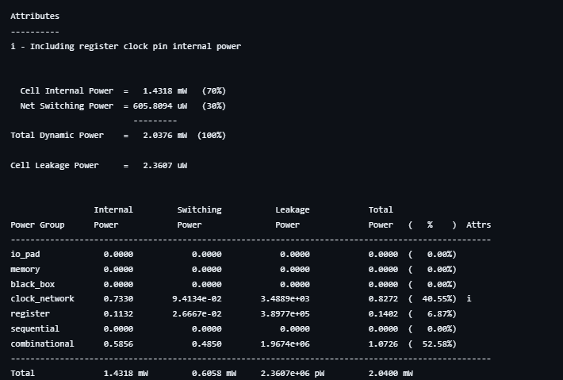
Gated: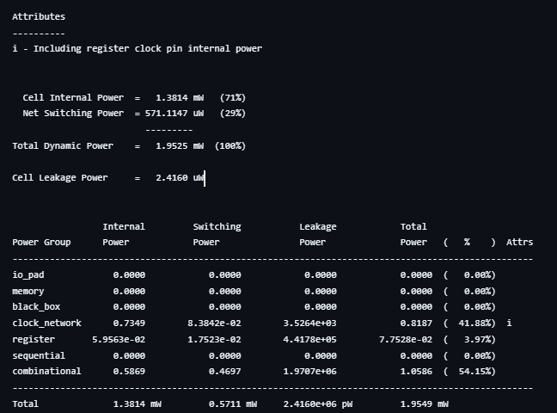
As expected, clock gating provides better power optimization by disabling the clock signal to idle components

Area report:
Not gated:
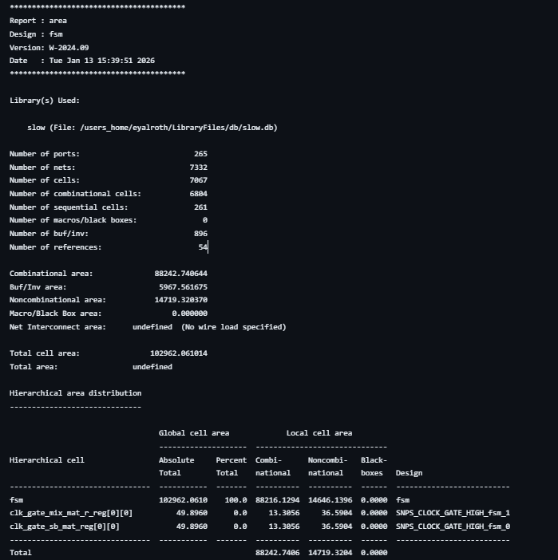

Gated:
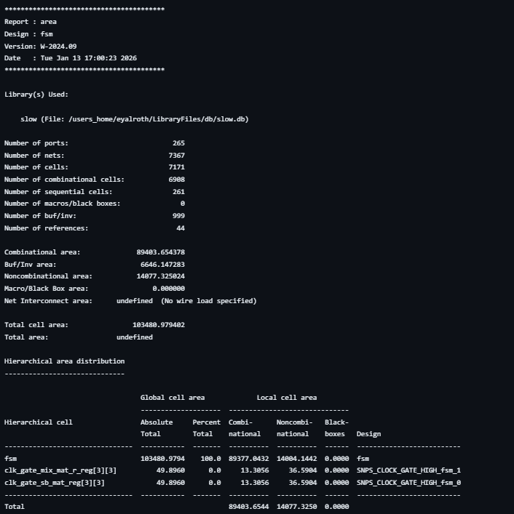
As expected the ungated clock is better than the gated clock because it requires fewer physical resources.

Timing report:
We set the period time to be 10 ns.
Not gated (worst case):
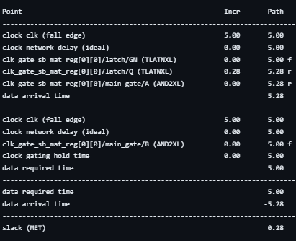

$$T_{min}= T_{current}-slack=10-0.28=9.72$$
$$F_{\max{}}= \frac{1}{T_{critical}}=102.88MHZ$$

Gated (worst case):
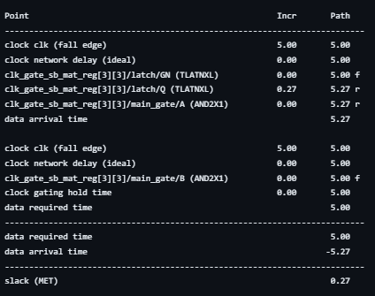
$$T_{min}= T_{current}-slack=10-0.27=9.73$$

$$F_{\max{}}= \frac{1}{T_{critical}}=102.77MHZ$$
As predicted the gated clock is slower than ungated clock due to the added propagation delay of the gating element.

